Mastering Embedded System

Online Diploma

[www.learn-in-depth.com](https://www.learn-in-depth.com/)

First Term (Final Project 1)

Eng. Omar Khaled M. Anwer

My Profile:

# Contents

Case Study 3

Requirement Diagram 4

System Analysis 5

Use Case Diagram 5

Activity Diagram 6

Sequence Diagram 7

System Design 8

Application 9

Pressure Sensor Module 10

Alarm Module 11

Compilation 12

Makefile 12

Startup code 14

Linker Script 16

Symbol table 17

Map file 18

Simulation 26

# Case Study

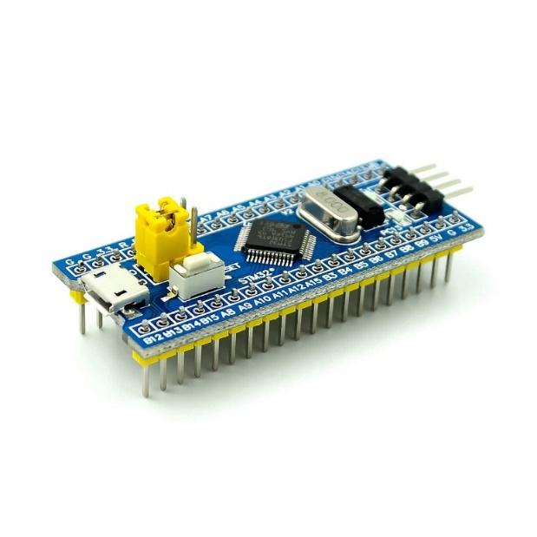 

**Specifications:**

* A pressure controller should inform the crew of a cabin  
  with an alarm when the pressure exceeds 20 bars in the cabin.
* The alarm duration equals 60 seconds.
* The system keeps tracking the measured values.

**Pressure Controller Assumptions**

* The controller set up and shutdown procedures are not modeled.
* The controller maintenance is not modeled.
* The pressure sensor never fails.
* The alarm never fails.
* The controller never faces power cut.

**Versioning:**

The “keeps tracking the measured values” option is not modeled in the first version of the design.

# Requirement Diagram

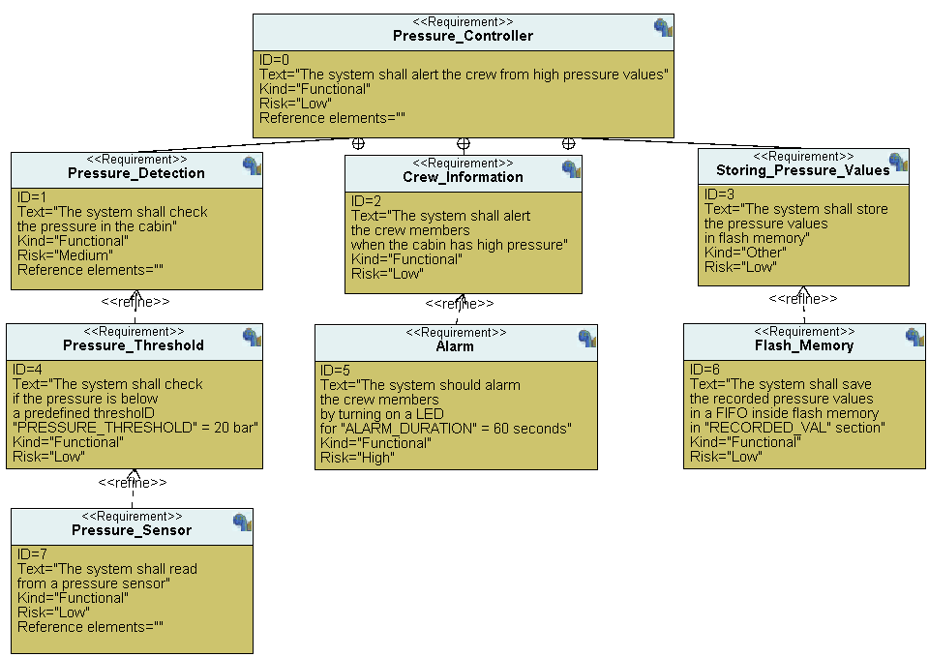

# System Analysis

## Use Case Diagram

## Activity Diagram

## Sequence Diagram

This sequence diagram describes a scenario of the system.

# System Design

**System Components**

* Pressure sensor
* Alarm actuator
* Main application

## Application

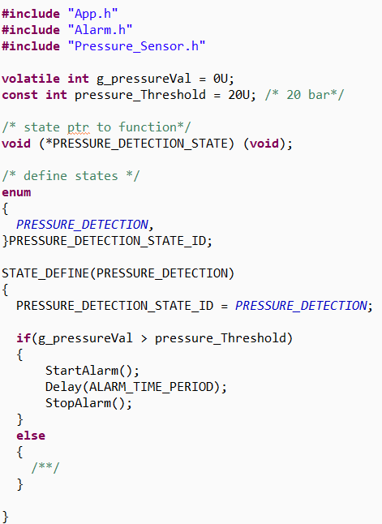

## Pressure Sensor Module

## Alarm Module

# Compilation

## Makefile

#@copyright : Omar Anwer

#Project name

**PROJECT_NAME** = Pressure_Controller

#Architectures Specific Flags

**CPU** = cortex-m3

**CFLAGS_ARCH** = **-mcpu**=$(CPU)

#CFLAGS_ARCH = -mcpu=$(CPU) -m$(ARCH) --specs=$(SPECS)

#Compiler Flags and Defines

**CC** = arm-none-eabi-

**DBGCFLAGS** = -g -gdwarf-2

**CFLAGS** = -ansi **-std**=c89 -O0 -Wall $(CFLAGS_ARCH) $(DBGCFLAGS)

#Linker Flags

**LINKER_FILE** = linker_script.ld

**LDFLAGS_ARCH** = -T $(LINKER_FILE)

**STARTUP_FILE** = startup.s

#includes

**INCS** = -I .

**LIBS** =

#.c and .s files

**SRC** = **$(wildcard** *.c**)**

**AS** = **$(wildcard** *.s**)**

**PRE** = $(SRC:.c=.i)

**SRCOBJ** = $(SRC:.c=.o)

**ASOBJ** = $(AS:.s=.o)

all: $(PROJECT_NAME).bin

@echo ""

@$(CC)size.exe $(PROJECT_NAME).elf

@echo ""

@echo "Building done..."

%.o: %.s

$(CC)as.exe $(INCS) $< -o $@

@echo ""

%.o: %.c

$(CC)gcc.exe -S $(INCS) $<

@echo ""

$(CC)gcc.exe -c $(CFLAGS) $(INCS) $< -o $@

@echo ""

%.i: %.c

$(CC)gcc.exe -E $(INCS) $< -o $@

@echo ""

$(PROJECT_NAME).elf: $(ASOBJ) $(SRCOBJ) $(PRE)

$(CC)ld.exe $(LDFLAGS_ARCH) $(LIBS) $(ASOBJ) $(SRCOBJ) -o $@ **-Map**=$(PROJECT_NAME).map

@echo ""

$(CC)objdump.exe -h $@

@echo ""

$(CC)readelf.exe -S $@

@echo ""

@cp $(PROJECT_NAME).elf $(PROJECT_NAME).axf

$(PROJECT_NAME).bin: $(PROJECT_NAME).elf

$(CC)objcopy.exe -O binary $< $@

@echo ""

$(CC)objcopy.exe -O ihex $< $(PROJECT_NAME).hex

@echo ""

clean:

@rm *.bin *.hex *.elf *.axf *.map

clean-all:

#@rm -rf $(filter-out $(STARTUP_FILE), $(AS))

@rm *.s

@rm *.i *.o *.bin *.hex *.elf *.axf *.map

@echo "All cleaned..."

## Startup code

**#include** <stdint.h>

/*#define stack_top 0x20001000*/

**extern** **int** **main**(**void**);

**extern** uint32_t _stack_top;

**extern** uint32_t _E_text;

**extern** uint32_t _S_data;

**extern** uint32_t _E_data;

**extern** uint32_t _S_bss;

**extern** uint32_t _E_bss;

**void** **Reset_Handler**(**void**)

{

/* copy .data section byte by byte from FLASH to SRAM */

uint8_t* pSrc = (uint8_t*)(&_E_text);

uint8_t* pDst = (uint8_t*)(&_S_data);

uint32_t DATA_SIZE = (uint8_t*)(&_E_data) - (uint8_t*)(&_S_data);

uint32_t i;

**for**(i = 0; i < DATA_SIZE; ++i)

{

*pDst = *pSrc;

pSrc++;

pDst++;

}

/* initialize .data section in SRAM */

pDst = (uint8_t*)(&_S_bss);

uint32_t BSS_SIZE = (uint8_t*)(&_E_bss) - (uint8_t*)(&_S_bss);

**for**(i = 0; i < BSS_SIZE; ++i)

{

*pDst = 0;

pDst++;

}

/* jump to main() */

main();

}

/* initialize vectors */

**void** **Default_Handler**(**void**)

{

Reset_Handler();

}

**void** **NMI_Handler**(**void**) **__attribute__**(( weak, alias("Default_Handler") ));

**void** **H_fault_Handler**(**void**) **__attribute__**(( weak, alias("Default_Handler") ));

**void** **MM_fault_Handler**(**void**) **__attribute__**(( weak, alias("Default_Handler") ));

**void** **Bus_fault_Handler**(**void**) **__attribute__**(( weak, alias("Default_Handler") ));

**void** **Usage_fault_Handler**(**void**) **__attribute__**(( weak, alias("Default_Handler") ));

uint32_t vectors[] **__attribute__**((section(".vectors"))) = {

(uint32_t) &_stack_top,

(uint32_t) &Reset_Handler,

(uint32_t) &NMI_Handler,

(uint32_t) &H_fault_Handler,

(uint32_t) &MM_fault_Handler,

(uint32_t) &Bus_fault_Handler,

(uint32_t) &Usage_fault_Handler,

};

## Linker Script

/*

Linker script Cortex-M3

By Eng.Omar

*/

ENTRY(Reset_Handler)

MEMORY

{

FLASH (rx) : ORIGIN = 0x08000000, LENGTH = 64K

SRAM (rwx) : ORIGIN = 0x20000000, LENGTH = 20K

}

SECTIONS

{

.text :

{

*(.vectors*)

*(.text*)

*(.rodata)

. = ALIGN(4);

_E_text = .;

}>FLASH

.data :

{

_S_data = .;

*(.data)

. = ALIGN(4);

_E_data = .;

}>SRAM AT>FLASH

.bss :

{

_S_bss = .;

*(.bss*)

_E_bss = .;

. = ALIGN(4);

. = . + 0x1000;

_stack_top = .; /*stack top after 4 KB*/

}>SRAM

}

## Symbol table

## 

## Map file

Memory Configuration

Name Origin Length Attributes

FLASH 0x08000000 0x00010000 xr

SRAM 0x20000000 0x00005000 xrw

*default* 0x00000000 0xffffffff

Linker script and memory map

.text 0x08000000 0x2dc

*(.vectors*)

.vectors 0x08000000 0x1c startup.o

0x08000000 vectors

*(.text*)

.text 0x0800001c 0xb0 Alarm.o

0x0800001c ST_ALARM_WAITING

0x08000034 ST_ALARM_ON

0x0800005c ST_ALARM_OFF

0x08000084 Alarm_Init

0x08000092 StartAlarm

0x080000b0 StopAlarm

.text 0x080000cc 0x34 App.o

0x080000cc ST_PRESSURE_DETECTION

.text 0x08000100 0x2c Pressure_Sensor.o

0x08000100 PressureSensor_Init

0x0800010c ST_PS_READING

.text 0x0800012c 0xc4 driver.o

0x0800012c Delay

0x0800014e GPIO_INITIALIZATION

0x080001a0 Set_Alarm_actuator

0x080001d8 getPressureVal

.text 0x080001f0 0x50 main.o

0x080001f0 main

.text 0x08000240 0x98 startup.o

0x08000240 Reset_Handler

0x080002cc MM_fault_Handler

0x080002cc Usage_fault_Handler

0x080002cc Bus_fault_Handler

0x080002cc Default_Handler

0x080002cc H_fault_Handler

0x080002cc NMI_Handler

*(.rodata)

.rodata 0x080002d8 0x4 App.o

0x080002d8 pressure_Threshold

0x080002dc . = ALIGN (0x4)

0x080002dc _E_text = .

.glue_7 0x080002dc 0x0

.glue_7 0x080002dc 0x0 linker stubs

.glue_7t 0x080002dc 0x0

.glue_7t 0x080002dc 0x0 linker stubs

.vfp11_veneer 0x080002dc 0x0

.vfp11_veneer 0x080002dc 0x0 linker stubs

.v4_bx 0x080002dc 0x0

.v4_bx 0x080002dc 0x0 linker stubs

.iplt 0x080002dc 0x0

.iplt 0x080002dc 0x0 Alarm.o

.rel.dyn 0x080002dc 0x0

.rel.iplt 0x080002dc 0x0 Alarm.o

.data 0x20000000 0x0 load address 0x080002dc

0x20000000 _S_data = .

*(.data)

.data 0x20000000 0x0 Alarm.o

.data 0x20000000 0x0 App.o

.data 0x20000000 0x0 Pressure_Sensor.o

.data 0x20000000 0x0 driver.o

.data 0x20000000 0x0 main.o

.data 0x20000000 0x0 startup.o

0x20000000 . = ALIGN (0x4)

0x20000000 _E_data = .

.igot.plt 0x20000000 0x0 load address 0x080002dc

.igot.plt 0x20000000 0x0 Alarm.o

.bss 0x20000000 0x101c load address 0x080002dc

0x20000000 _S_bss = .

*(.bss*)

.bss 0x20000000 0x5 Alarm.o

0x20000000 ALARM_STATE

0x20000004 ALARM_STATE_ID

*fill* 0x20000005 0x3

.bss 0x20000008 0x9 App.o

0x20000008 g_pressureVal

0x2000000c PRESSURE_DETECTION_STATE

0x20000010 PRESSURE_DETECTION_STATE_ID

*fill* 0x20000011 0x3

.bss 0x20000014 0x5 Pressure_Sensor.o

0x20000014 PS_STATE

0x20000018 PS_STATE_ID

.bss 0x20000019 0x0 driver.o

.bss 0x20000019 0x0 main.o

.bss 0x20000019 0x0 startup.o

0x20000019 _E_bss = .

0x2000001c . = ALIGN (0x4)

*fill* 0x20000019 0x3

0x2000101c . = (. + 0x1000)

*fill* 0x2000001c 0x1000

0x2000101c _stack_top = .

LOAD Alarm.o

LOAD App.o

LOAD Pressure_Sensor.o

LOAD driver.o

LOAD main.o

LOAD startup.o

OUTPUT(Pressure_Controller.elf elf32-littlearm)

LOAD linker stubs

.debug_info 0x00000000 0x6ea

.debug_info 0x00000000 0x163 Alarm.o

.debug_info 0x00000163 0x116 App.o

.debug_info 0x00000279 0x10b Pressure_Sensor.o

.debug_info 0x00000384 0x10c driver.o

.debug_info 0x00000490 0xc5 main.o

.debug_info 0x00000555 0x195 startup.o

.debug_abbrev 0x00000000 0x472

.debug_abbrev 0x00000000 0xe3 Alarm.o

.debug_abbrev 0x000000e3 0xbf App.o

.debug_abbrev 0x000001a2 0xcb Pressure_Sensor.o

.debug_abbrev 0x0000026d 0xc5 driver.o

.debug_abbrev 0x00000332 0x6e main.o

.debug_abbrev 0x000003a0 0xd2 startup.o

.debug_loc 0x00000000 0x3a4

.debug_loc 0x00000000 0x120 Alarm.o

.debug_loc 0x00000120 0x2c App.o

.debug_loc 0x0000014c 0x70 Pressure_Sensor.o

.debug_loc 0x000001bc 0x140 driver.o

.debug_loc 0x000002fc 0x2c main.o

.debug_loc 0x00000328 0x7c startup.o

.debug_aranges 0x00000000 0xc0

.debug_aranges

0x00000000 0x20 Alarm.o

.debug_aranges

0x00000020 0x20 App.o

.debug_aranges

0x00000040 0x20 Pressure_Sensor.o

.debug_aranges

0x00000060 0x20 driver.o

.debug_aranges

0x00000080 0x20 main.o

.debug_aranges

0x000000a0 0x20 startup.o

.debug_line 0x00000000 0x431

.debug_line 0x00000000 0x7f Alarm.o

.debug_line 0x0000007f 0x51 App.o

.debug_line 0x000000d0 0x68 Pressure_Sensor.o

.debug_line 0x00000138 0x120 driver.o

.debug_line 0x00000258 0x85 main.o

.debug_line 0x000002dd 0x154 startup.o

.debug_str 0x00000000 0x317

.debug_str 0x00000000 0x171 Alarm.o

0x1cb (size before relaxing)

.debug_str 0x00000171 0x72 App.o

0x1c2 (size before relaxing)

.debug_str 0x000001e3 0x49 Pressure_Sensor.o

0x19f (size before relaxing)

.debug_str 0x0000022c 0x57 driver.o

0x19d (size before relaxing)

.debug_str 0x00000283 0xc main.o

0x177 (size before relaxing)

.debug_str 0x0000028f 0x88 startup.o

0x1dc (size before relaxing)

.comment 0x00000000 0x49

.comment 0x00000000 0x49 Alarm.o

0x4a (size before relaxing)

.comment 0x00000049 0x4a App.o

.comment 0x00000049 0x4a Pressure_Sensor.o

.comment 0x00000049 0x4a driver.o

.comment 0x00000049 0x4a main.o

.comment 0x00000049 0x4a startup.o

.ARM.attributes

0x00000000 0x2d

.ARM.attributes

0x00000000 0x2d Alarm.o

.ARM.attributes

0x0000002d 0x2d App.o

.ARM.attributes

0x0000005a 0x2d Pressure_Sensor.o

.ARM.attributes

0x00000087 0x2d driver.o

.ARM.attributes

0x000000b4 0x2d main.o

.ARM.attributes

0x000000e1 0x2d startup.o

.debug_frame 0x00000000 0x250

.debug_frame 0x00000000 0xbc Alarm.o

.debug_frame 0x000000bc 0x2c App.o

.debug_frame 0x000000e8 0x4c Pressure_Sensor.o

.debug_frame 0x00000134 0xa0 driver.o

.debug_frame 0x000001d4 0x2c main.o

.debug_frame 0x00000200 0x50 startup.o

# Simulation

[Simulaton video](https://github.com/Omar-Anwer/learn-in-depth-Embedded-Diploma/blob/main/First%20Term%20Project%201/Proteus_Simulation/Proteus_Video.mp4)

